Document Version: 0.1

Describing the process of Uploading Test scripts in MTM:
If you want to upload test cases, jump to Part 2

Part 1: Create User story name in MTM.

Steps to create user story name:
- Open MTM
- Click on ‘New’ dropdown
- Select ‘User story’

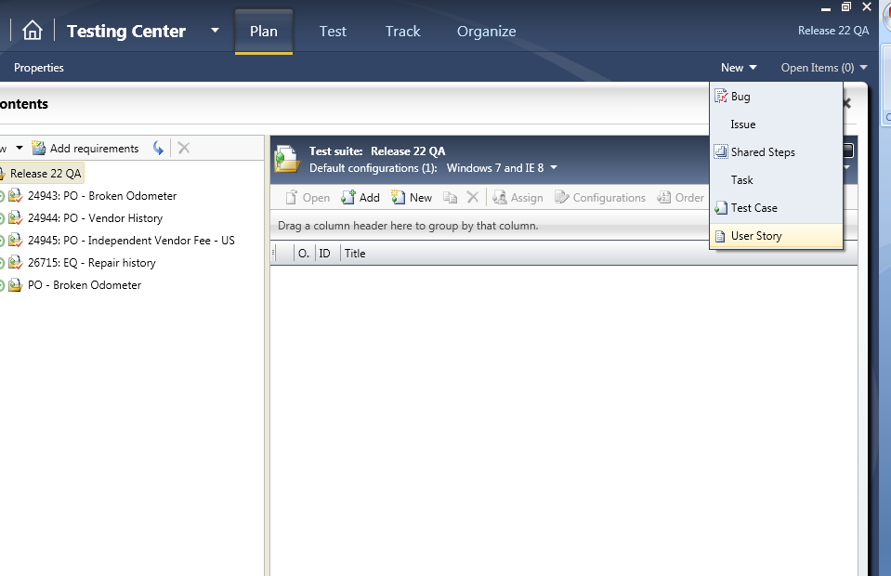

- Enter ‘Title’ as name of the story(Format Ex: <Track ID:PO>_<Story Name>)
- Select ‘Area’
- Select ‘Iteration’
- Click on ‘Save and close’ button

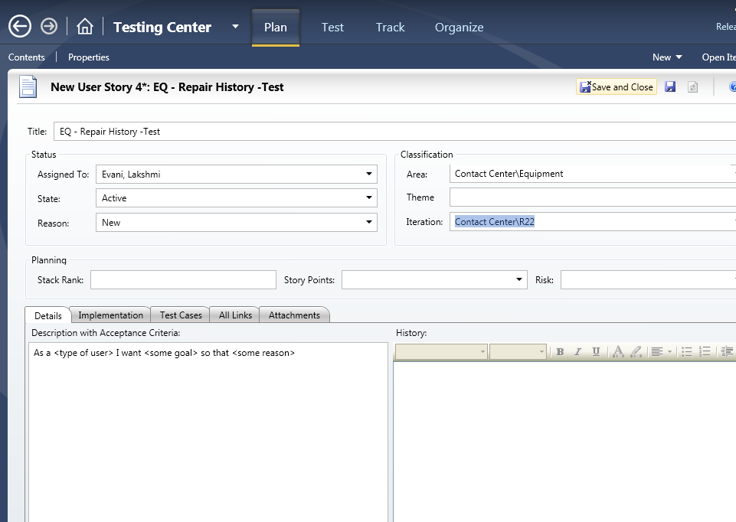

- Click on Home link

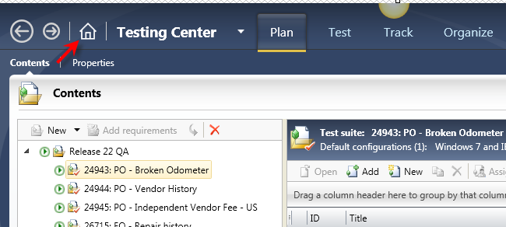

- Select the appropriate Test Plan as mentioned in the below screen shot (Ex: Release 22 QA)
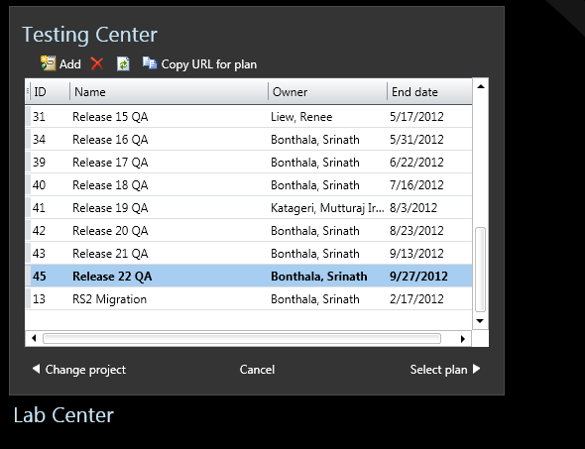

- click on Add requirements

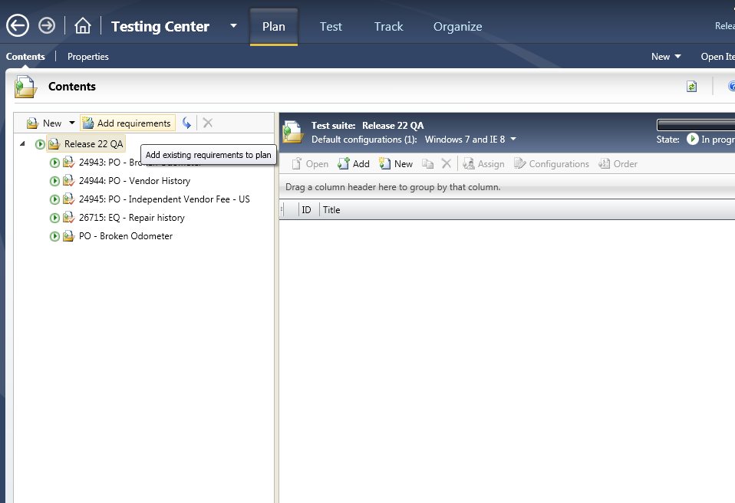

- Create a Query using work item type, Area path, created date and run the query (refer to below screenshot for sample)

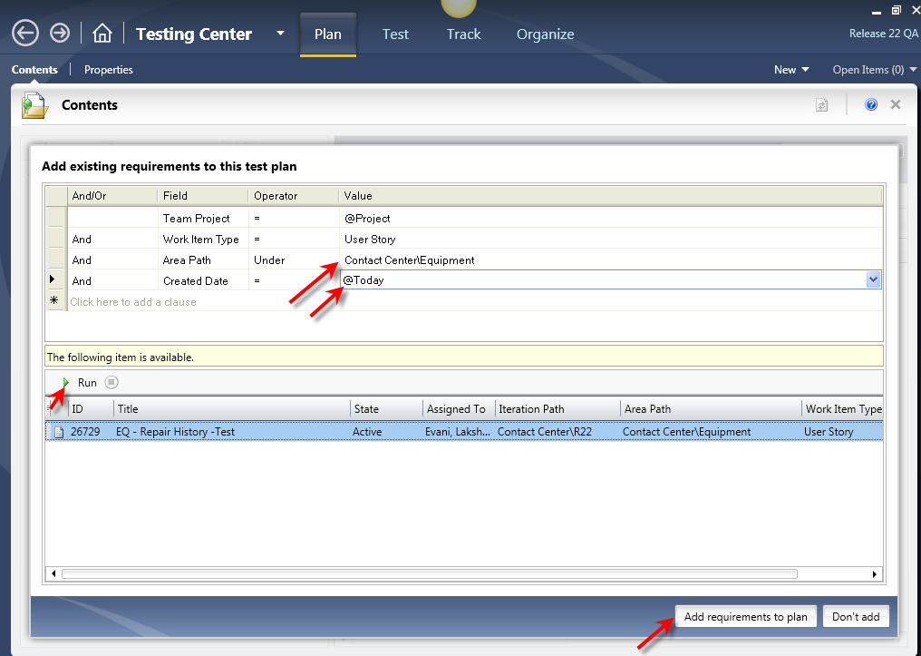

- Click on ‘Add Requirements to plan’ button
- Selected user story will be displayed under release plan

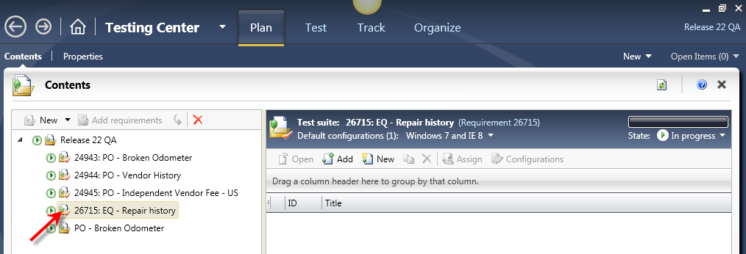

Part 2: Transfer test scripts in MTM Upload Sheet
Steps to transfer test scripts:

- Open the MTM upload sheet attached
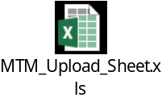
- Transfer Test case in to upload sheet as per below mapping.
  - Test Name: Test Script Name
  - Test Description: Test Script Description
  - Test Folder Hierarchy: MTM Area Path
  - Assigned To: Tester Name (Last, First)
  - Status: Design
  - Priority: 2
  - Suites Hierarchy (test belongs to these suites): <Test Plan Name> \ <User Story Name> - Example: Release 22 QA \ EQ – Repair History
  - Related Test Case Source IDs: MTM Iteration Path
  - Linked Requirement Source ID: Leave it Blank
  - Step Name: Steps to Test (from Test case)
  - Expected Results: Expected Results (from Test Case)

Below is the sample filled form:
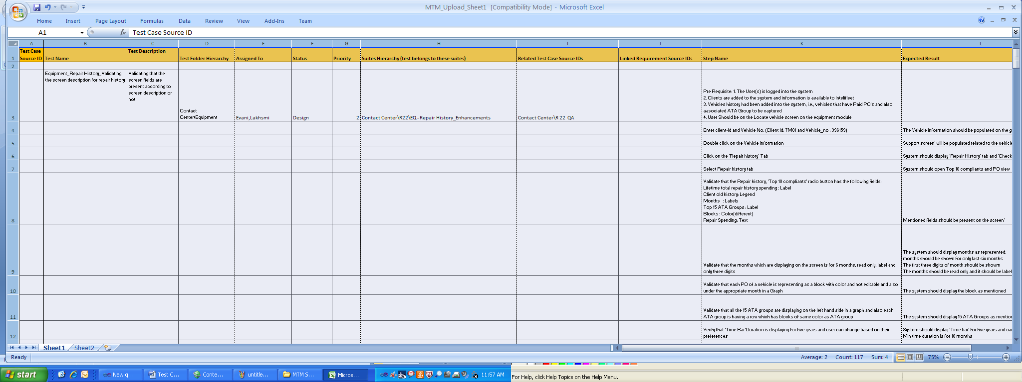
- Leave one line in between each test script
- Save it
Part 3: Upload the filled sheet in MTM through Test Case Migrator Plus
- Open ‘Test Case Migrator Plus’ tool
(Open the MigratorPlus.exe from wherever it’s placed)

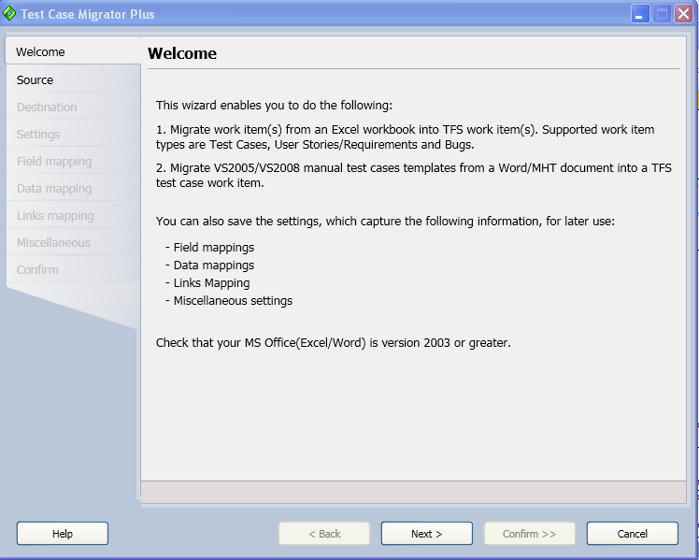

- Click on ‘Next’ button and Browse MTM Upload sheet (filled above)

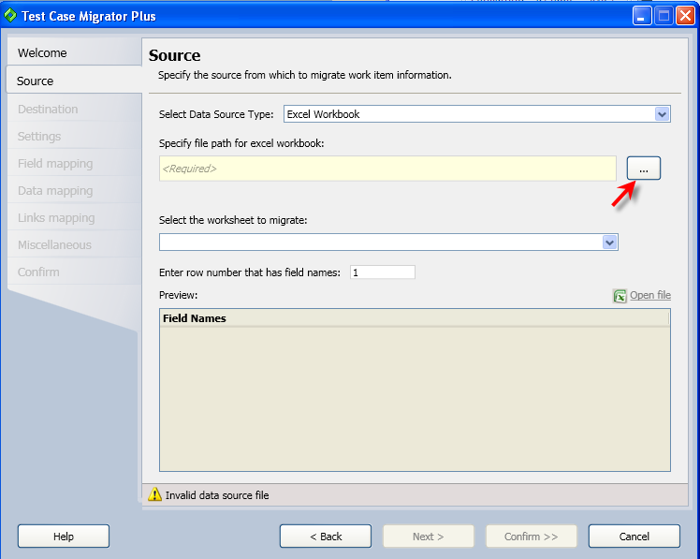

- Click on ‘Next’ button

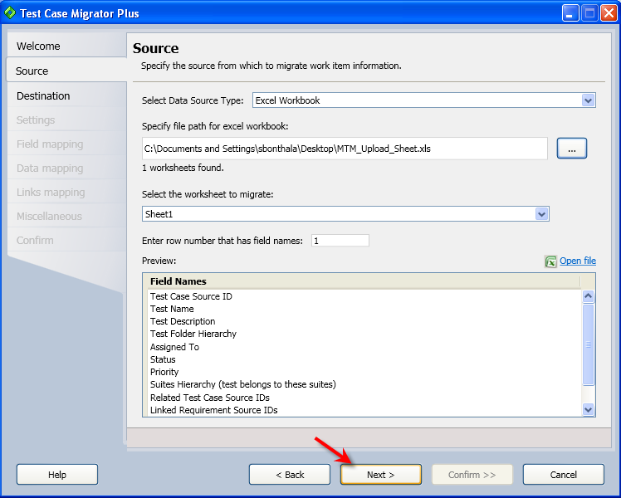

- Click on ‘Next’ Button

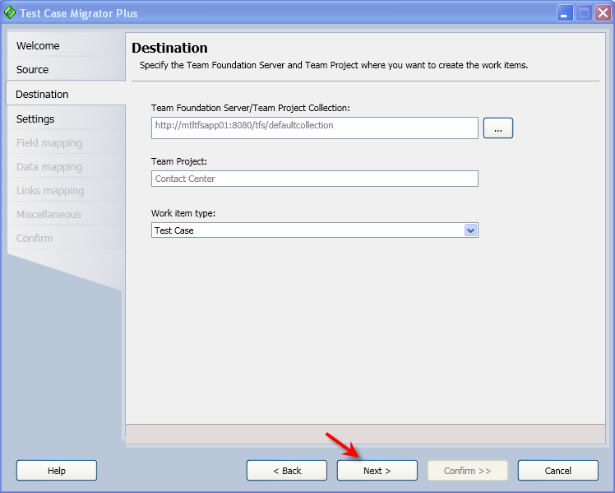

- Select ‘Load from existing setting file’ radio button and browse the following XML file.
File name: MyTestCaseSettingsFile.xml (Please use the below file. Please it in your machine and load from there.)
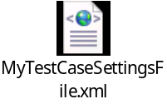

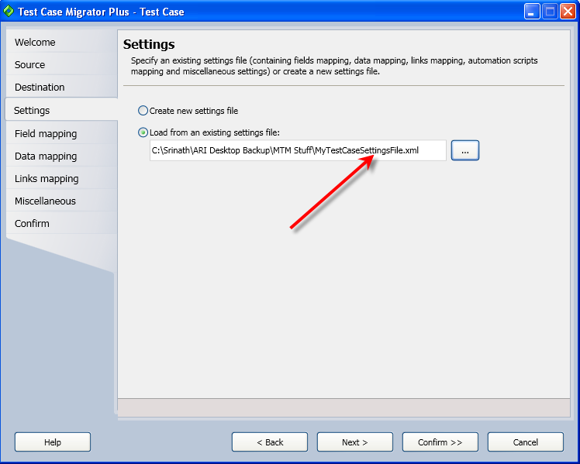

- Click on ‘Next’ button

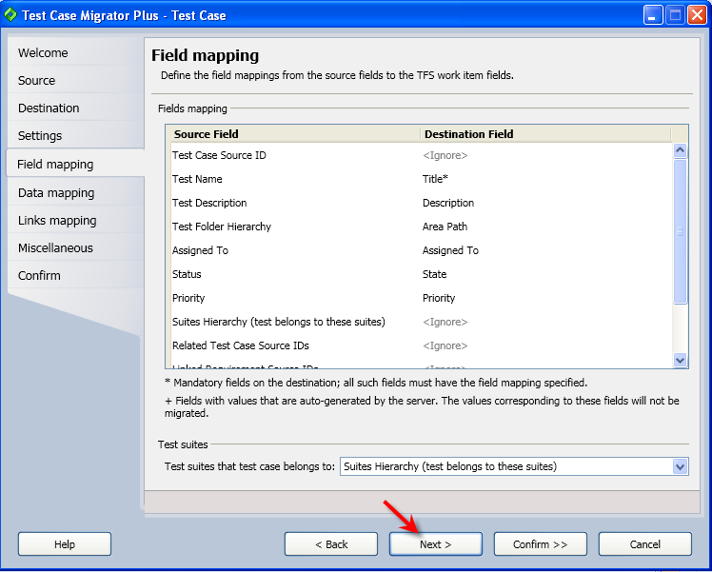

- Select ‘Related Test Case Source IDs’ as ‘Iteration Path’

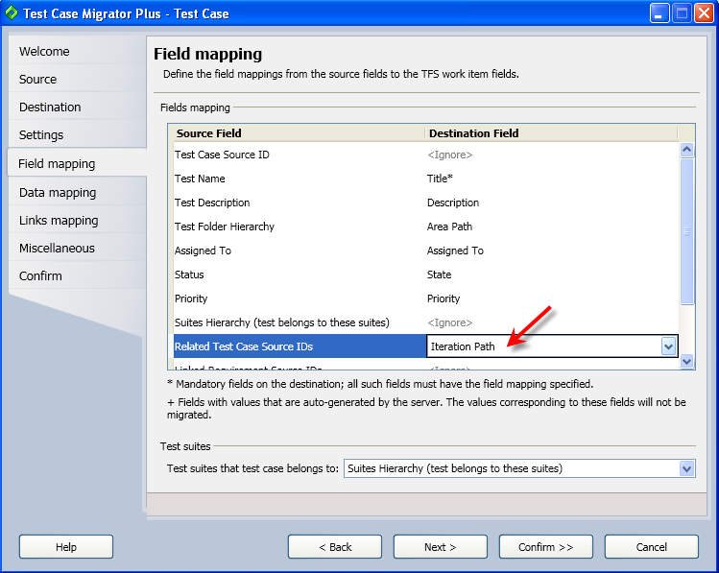

- Click on ‘Next’ button and select destination values as mentioned below (Select Assigned to as ‘@username’, Status as ‘Design’ and Priority as ‘2’ (Default severity)

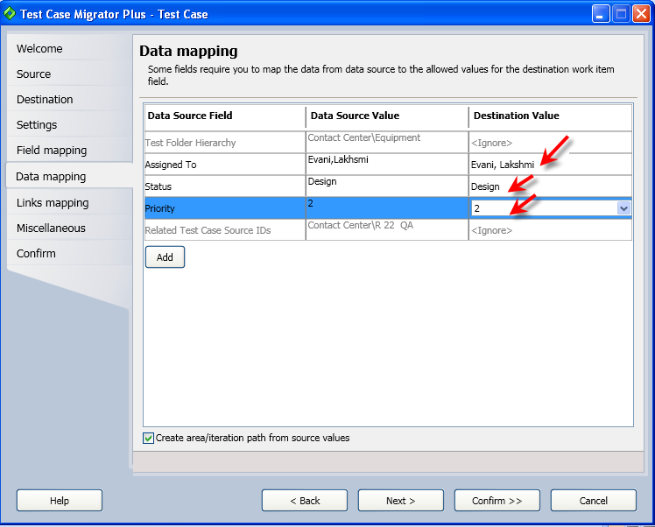

- Click on ‘Next’ Button and uncheck ‘Create links between work items’

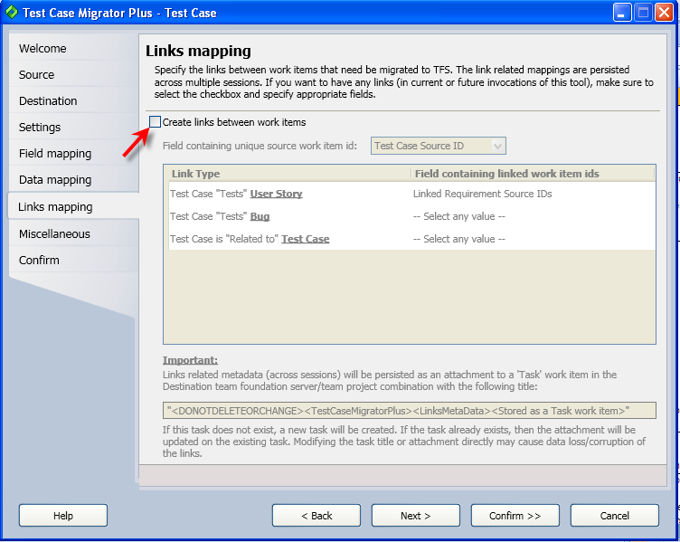

- Click on ‘Next’

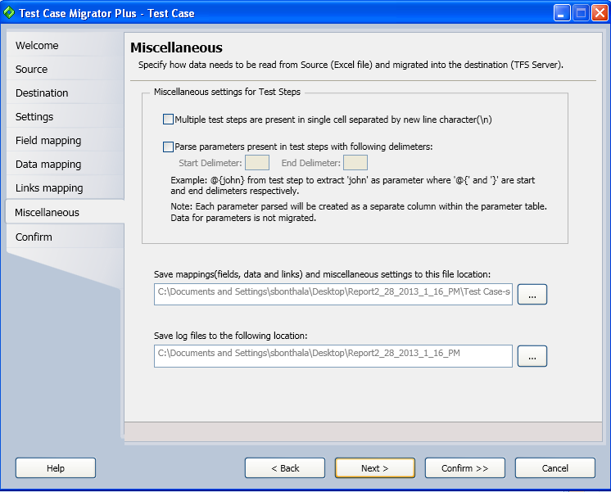

- Click on ‘Next’ Button

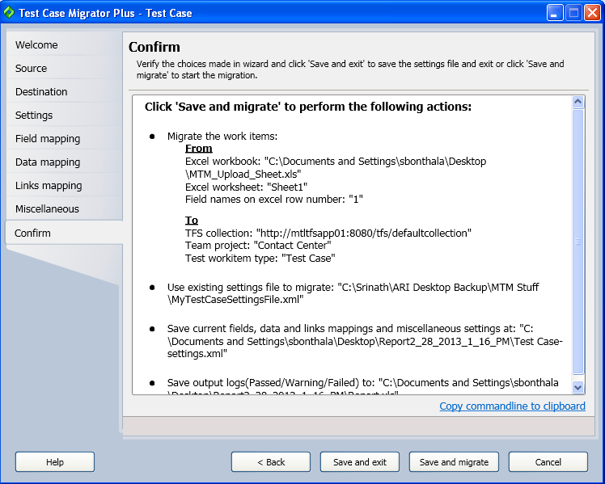

- Click on ‘Save and Migrate’ button

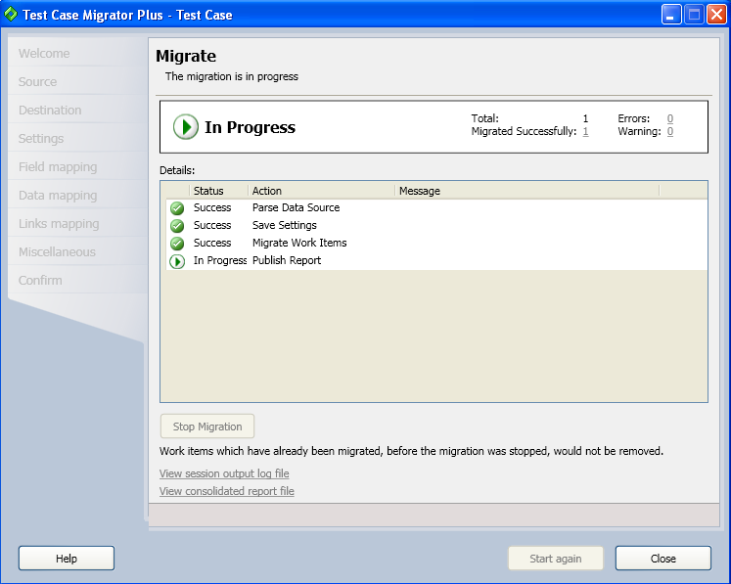

- Click on ‘Close’ button (after successful message displays)

Part 4: Add the Uploaded test cases under user story

- Open MTM
- Go to appropriate Plan and select ‘user story’ that is created above

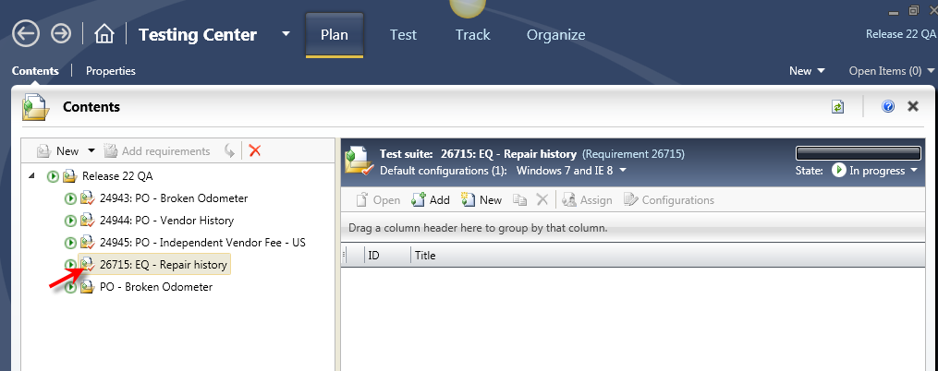
- Click on ‘Add’ button

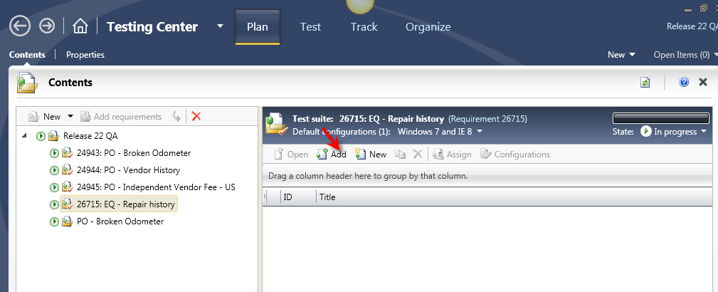

- Create a query to pull the uploaded test case (refer below sample query)

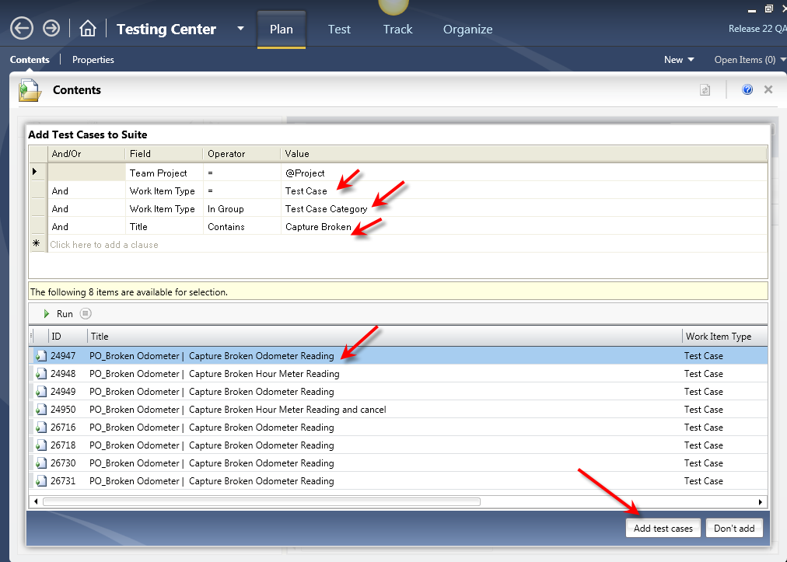

- Select the test case and click on ‘Add Test Cases’ button (Note: if multiple test cases need to selected then use ‘Ctrl’ key)

